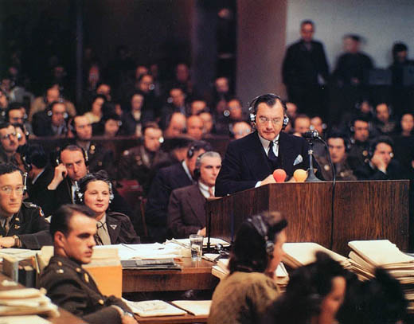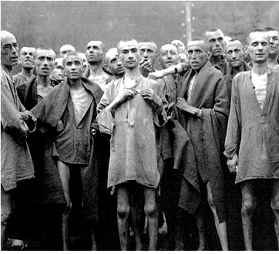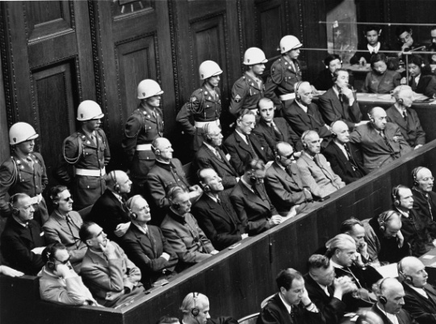
The London Conference and Nuremberg Trials
A Play for Classroom Use
Cast:
Historical Characters in Play: Student Actor’s Name:
Justice Robert H. Jackson _________________
Russian General Kikitchencko _________________
Robert Falco of France _________________
Chancellor Jowitt of Great Britain _________________
News Reporter #1 _________________
News Reporter #2 _________________
News Reporter #3 _________________

Background for Students:
In late April, 1945, President Truman asked Justice Robert H. Jackson to be the chief prosecutor for the proposed trials of the major Nazi leaders. Jackson accepted the position, and flew to London to meet with representatives from the other winning countries in World War Two--Britain, France, and the Soviet Union. Their meeting became known as the London Conference, setting the course for what became known as the Nuremberg Trials. So let us go now to England—and let this play begin.
President Harry Truman with Justice Robert H. Jackson, 1945
Scene One: The London Conference, Summer 1945
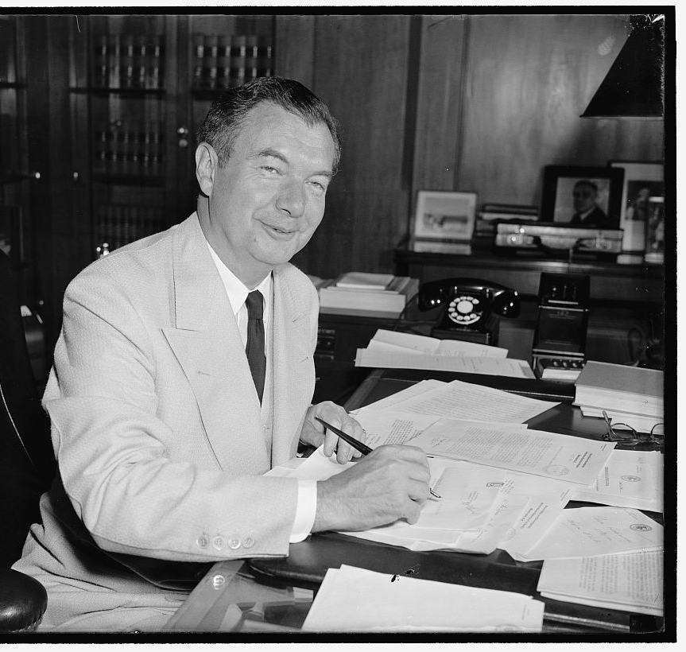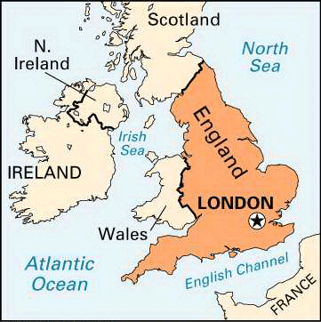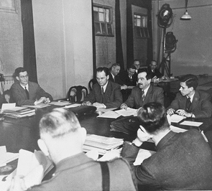
Justice Robert H. Jackson Map of Great Britain The London Conference

Chancellor Jowitt for Great Britain:
Gentlemen, as far as England is concerned, all the Nazi leaders should be executed! After all, we have 250 tons of documents and 3,000 frames of microfilm that tell us that they were proud of what they did during the war. They are guilty and should be hung!

Justice Jackson:
Indeed, we are getting proof of these crimes better than I expected. I didn’t think the Germans would be so foolish as to put all their work in writing. However, as Americans, we believe that the Nazis should receive a fair trial, with lawyers of their own to defend them. There should also be neutral judges who will first listen to the evidence without judging the defendants beforehand.

General Kikitchencko:
I agree--but as Russians, we believe that the job of the trial is to simply show the evidence--then provide a judgment of guilty. You know, anything can happen in a trial. We can't risk that any one of these criminals be declared "not guilty". Too many of our countrymen lost their lives at the hands of these Nazi savages!

Justice Jackson:
That is a risk we need to take. After all, you don’t put man on trial unless you are willing to set him free. We must never forget that the record on which we judge these defendants today is the record on which history will judge us tomorrow!

Robert Falco for France:
But what I don't understand is how can we charge them for breaking laws when they weren't notified beforehand? Aren't these trials accusing them of breaking laws that didn’t exist at the time?

Justice Jackson:
The trials would be enforcing international laws and treaties that were already there--such as the Kellogg-Briand Pact and the Treaty of Versailles. Besides, the trials would leave a record of the whole history of the Nazi movement. This way, the atrocities they committed will be shared to the world, and future war crimes might be prevented because heads of state will fear being put on trial themselves.

Robert Falco for France:
But how can we have trials for the thousands of Nazi soldiers who committed these crimes? Wouldn't they take a lifetime? The world wants justice now!

Justice Jackson:
I agree. That is why I feel only the major Nazi leaders be tried, including bankers, propaganda writers, and other politicians. No one should be able to claim that they were just following orders.

General Kikitchencko:
I agree. Let us come together in unity to get the job done!

Scene Two:
The Beginning of the Nuremberg Trials, November 21, 1945
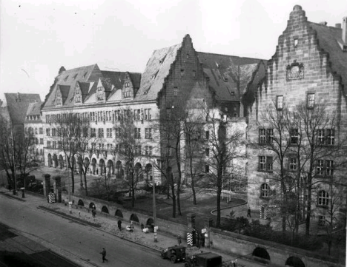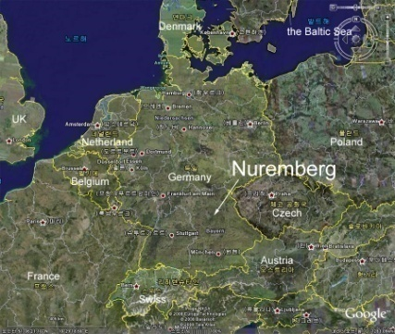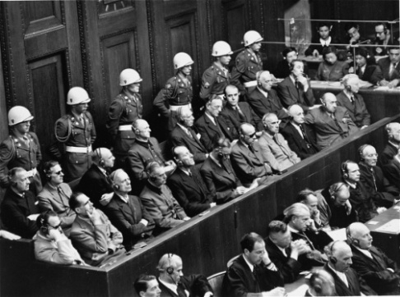
The Palace of Justice at Nuremberg Map of Germany Nazi leaders on trial

News Reporter #1:
We are here today at the historic Palace of Justice in the German city of Nuremberg. Over 400 visitors and 325 reporters have gathered to witness the trials of the 24 Nazi leaders who made the laws that led to the murder of millions.

News Reporter #2:
Today 8 judges from the winning countries in the war will form the International Military Tribunal--or trial. This will be a chance for justice to catch up with evil.

News Reporter #3:
Why are so many people in the courtroom wearing headphones--and sunglasses?
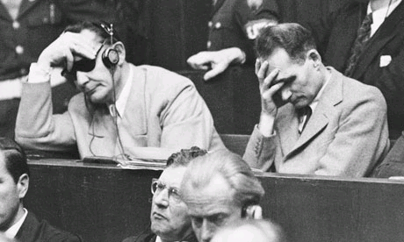
Nazi leaders on trial
News Reporter #1:
The headphones are there to allow the trials to be translated into three different languages--German, Russian, and French. The reason for the sunglasses is that it’s very bright in there. The courtroom was designed so that the video cameras could have the best light possible to show these trials to the rest of the world. Too bad Hitler committed suicide. It would have been nice to see him on trial too.

News Reporter #2:
I agree. Yesterday all the Nazis plead "Not Guilty", saying they were just following orders. It will be interesting to see how Jackson responds. This isn't going to be easy--and the results aren't guaranteed.

News Reporter #3:
His opening statement really spoke to the future as well. If tyrants know that they will face charges, they might think twice about committing crimes of their own.

News Reporter #1:
The evidence is incredible! To paraphrase the numbers he stated:
“The plan was so devastating that only remnants of the European Jews survived. Over five million are missing and over four million cannot be accounted for. History does not record a crime with so many victims that was carried out with such cruelty.”
Justice Jackson opening the Nuremberg Trials, November 21st, 1945
Teachers: Return to lesson plan website, going to Step Three

